W2L Websites and Apps

General apps, e.g., padlet, morfo, puppet pals, quizlet, book creator, QR Codes, purple mash, jit etc. Can be used successfully within Welsh Sessions.

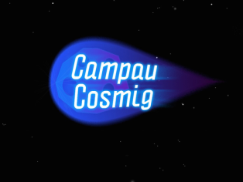
KS2
Campau Cosmig app – wordsearches, complete the sentence spelling words game. Topics include hobbies, travel, time.

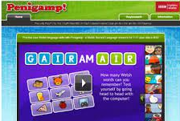
Penigamp website.
https://www.bbc.co.uk/wales/learning/penigamp - engaging games with familiar and appropriate language patterns on the whole. Mainly upper KS2, although Caffi Glan Môr game suitable for upper FP and lower KS2.

Learn Welsh.net website –
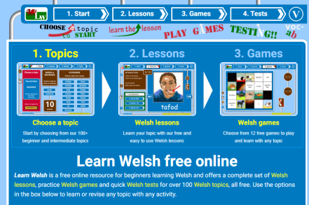
https://www.learn-welsh.net/ - is a little visually busy. Range of topics including hobbies, food, colours. Suitable for upper FP through KS2. Mainly vocabulary and basic sentences. Choice of games repeated for each topic. Lessons, games and tests included in a step-by=step approach. Mainly familiar vocab.

