

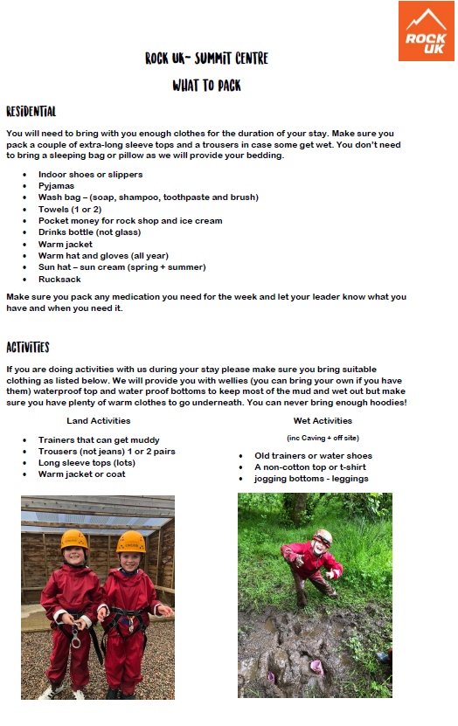
Maximum £5 pocket money, preferably in change
Bring a bin bag to put any wet clothes in.
You will need LOTS of pairs of socks!!
Don’t forget your suncream!!
What NOT to bring…
Mobile phone
Tablet
Smartwatch
Information

Dates: Wednesday 28th – Friday 30th June

Location: Rock UK Summit Centre, The Old Drift Mine, Trelewis, Treharris CF46 6RD

Timing: Please drop your child off at Rock UK at 2:30pm on the Wednesday. Pick up is at 1:00pm after lunch on the Friday.

Activities are likely to include:
- Aerial Adventure
- Archery
- Abseiling and Vertical Challenge
- Caving
- Climbing
- Crate Stack

In case of emergency, contact the school between 8:00am and 4:00pm, or email Miss Boanas on boanasa5@sch.caerphilly.gov.uk. Miss Boanas has access to her emails at all times. If there is an issue with your child, she will contact you directly.

