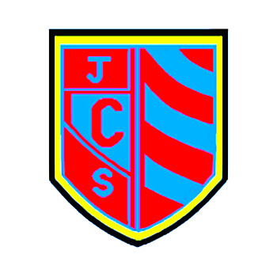

Distance Learning at Cwmaber Junior School
Top Tips to Stay Safe and Have Fun!!

Distance learning will help you to continue learning outside the classroom, particularly in these difficult times. It’s the perfect way to ensure that you still get the education you need, despite not being at school.
However, it also requires a level of discipline and commitment.
We have created these top tips to support you and ensure your experience is safe.
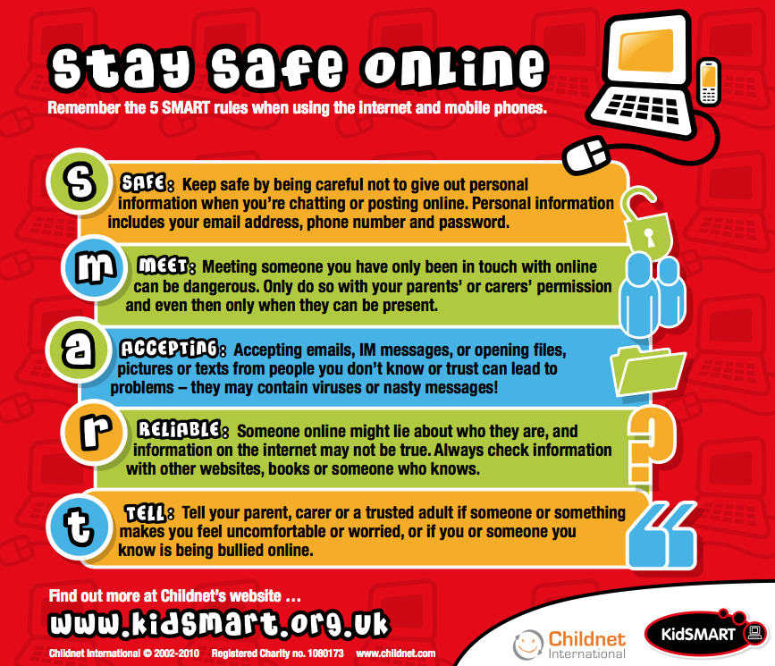
I will treat distance learning with the same respect as classroom learning  Focus on learning.  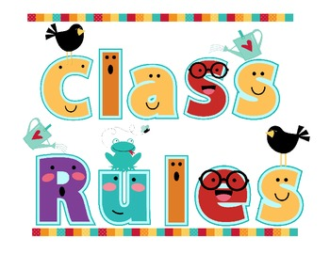  Remember the same rules apply as being in the classroom, particularly in respect of behaviour and conduct. | I will use appropriate classroom language  Write as though you would in class and avoid using shorthand text speak. Remember to always be respectful and polite and only post positive comments.
I will take regular screen breaks  In your spare time try to get some fresh air and enjoy other activities away from electronic devices. | I will always use our online e-safety SMART rules  S – Safe  M – Meet  A – Accepting  R – Reliable  T – Tell  Look at our website for full details.
I will keep my personal information secret  Always keep these safe and never share them with others. Remember a password is like a toothbrush. Don’t let anyone else use it!!  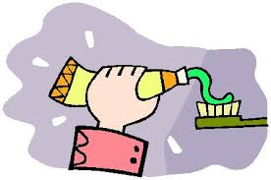 | I will always tell a trusted adult if something or someone makes me feel uncomfortable  Tell a trusted adult if you or someone you someone you know is being bullied. online. Cyber bullied.
I will look after my mental health and wellbeing alongside my distance learning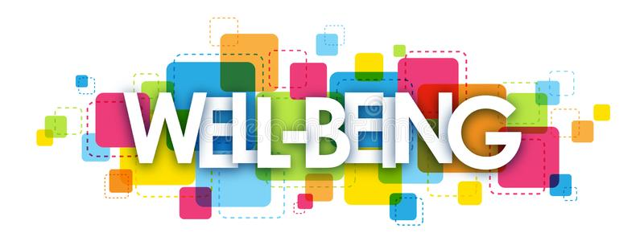  If you ever feel sad, it is important to discuss how you feel with a trusted adult. Keeping in touch with friends over the phone or via appropriate social media can also help to keep your spirits up. | I will be polite and show respect when communicating with others  Always maintain classroom behaviour and remember that you are in a learning environment and not a social setting.  

