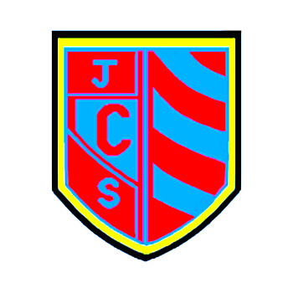

Distance Learning at Cwmaber Junior School
Check in, Catch up and Prepare for summer and September

Using Teams in Cwmaber Junior Guide for Parents

During your child’s weekly check in, catch up and preparation time they will be set work to do at home using:
- PurpleMash
- Reading Eggs
- Mathletics
- Teams
Each week they will be set work using Teams. This is a guide to using Teams:

- How to access Teams via Hwb. https://youtu.be/GEK0mr4EG3w

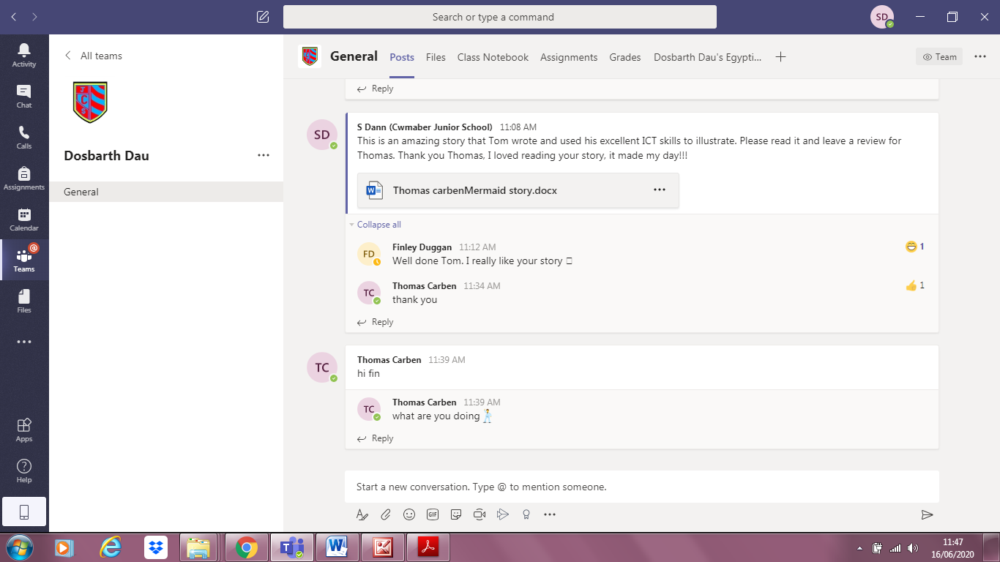
- Posts – this is where Pupils can Post things to their teacher or to their classmates. Also any work posted by the teacher will appear here. Polls can be set here and pupils can take part in the polls.

- File – This has three areas, Class Materials, this is where the class teacher saves work, this work cannot be edited by pupils. Downloads, all material that is downloaded is stored here. Files – these can be edited by pupils.

- Class Notebook - is a digital notebook for the whole class to store text, images, handwritten notes, attachments, links, voice, video, and more.

- Assignments – this is where work will be set for pupils. With an introduction from their teacher and resources attached for pupils. Pupils will be set their work in their catch up with the teacher then pupils are to complete the task at home.

