



‘

‘Working together to be the best we can be!’

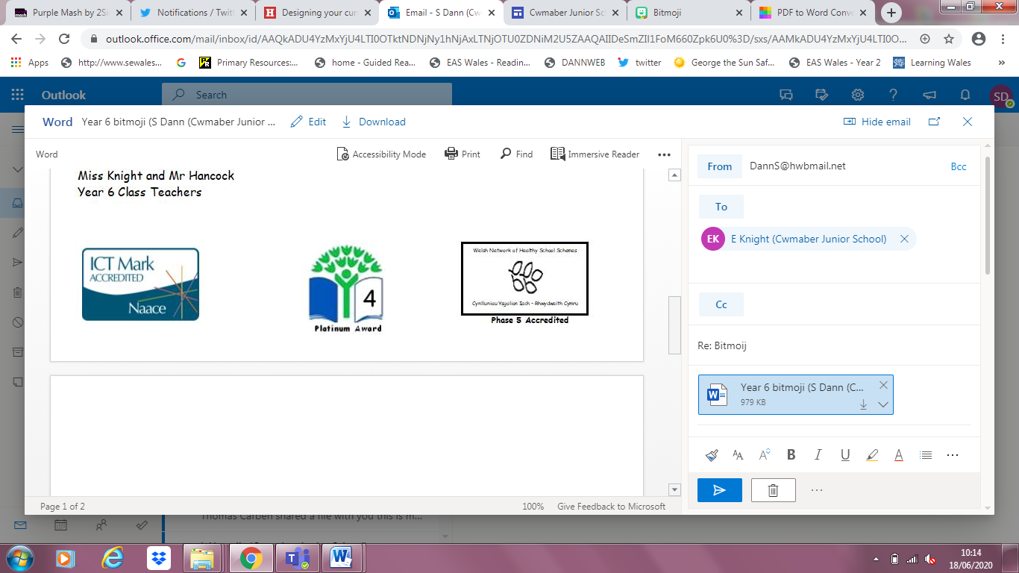
Welcome to Cwmaber Junior’s School Virtual Sports Week events. When you complete an activity, you record your score in the correct box. You need to complete at least 8 of the activities during the week beginning the 6th July!
We would love to see pictures and videos of you completing the activities!
Pob lwc and we hope you have fun!

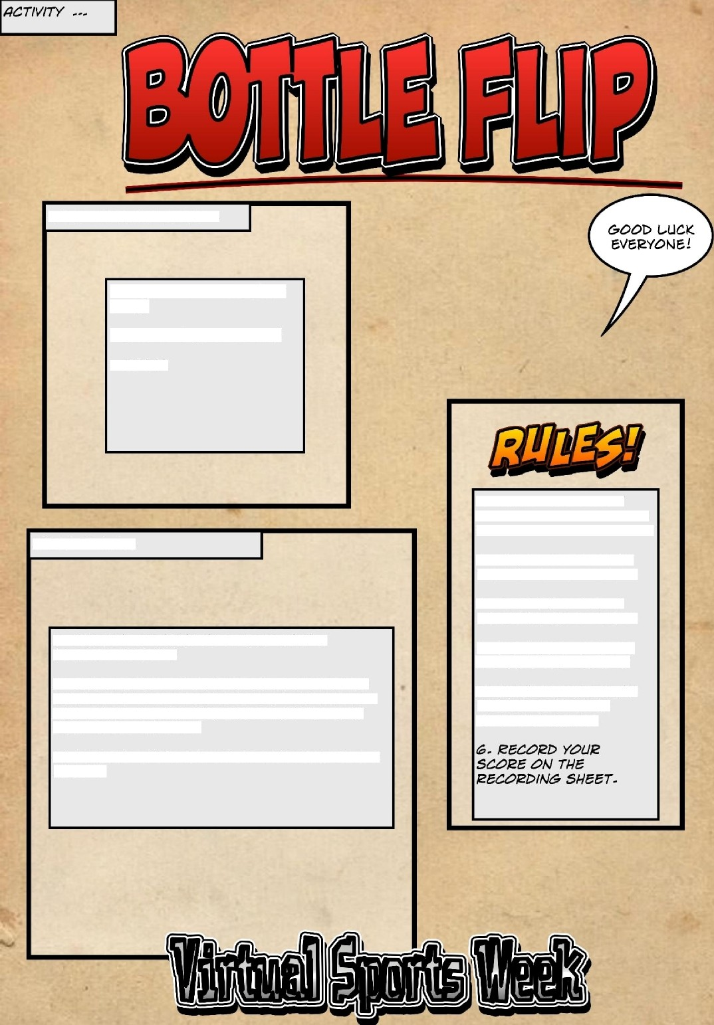
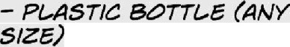
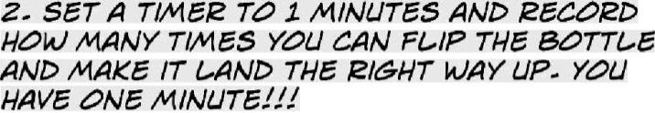
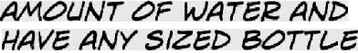
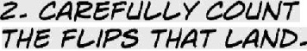
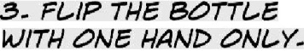
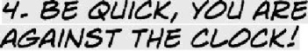
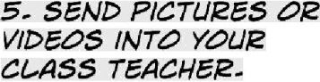

WHAT To Do---

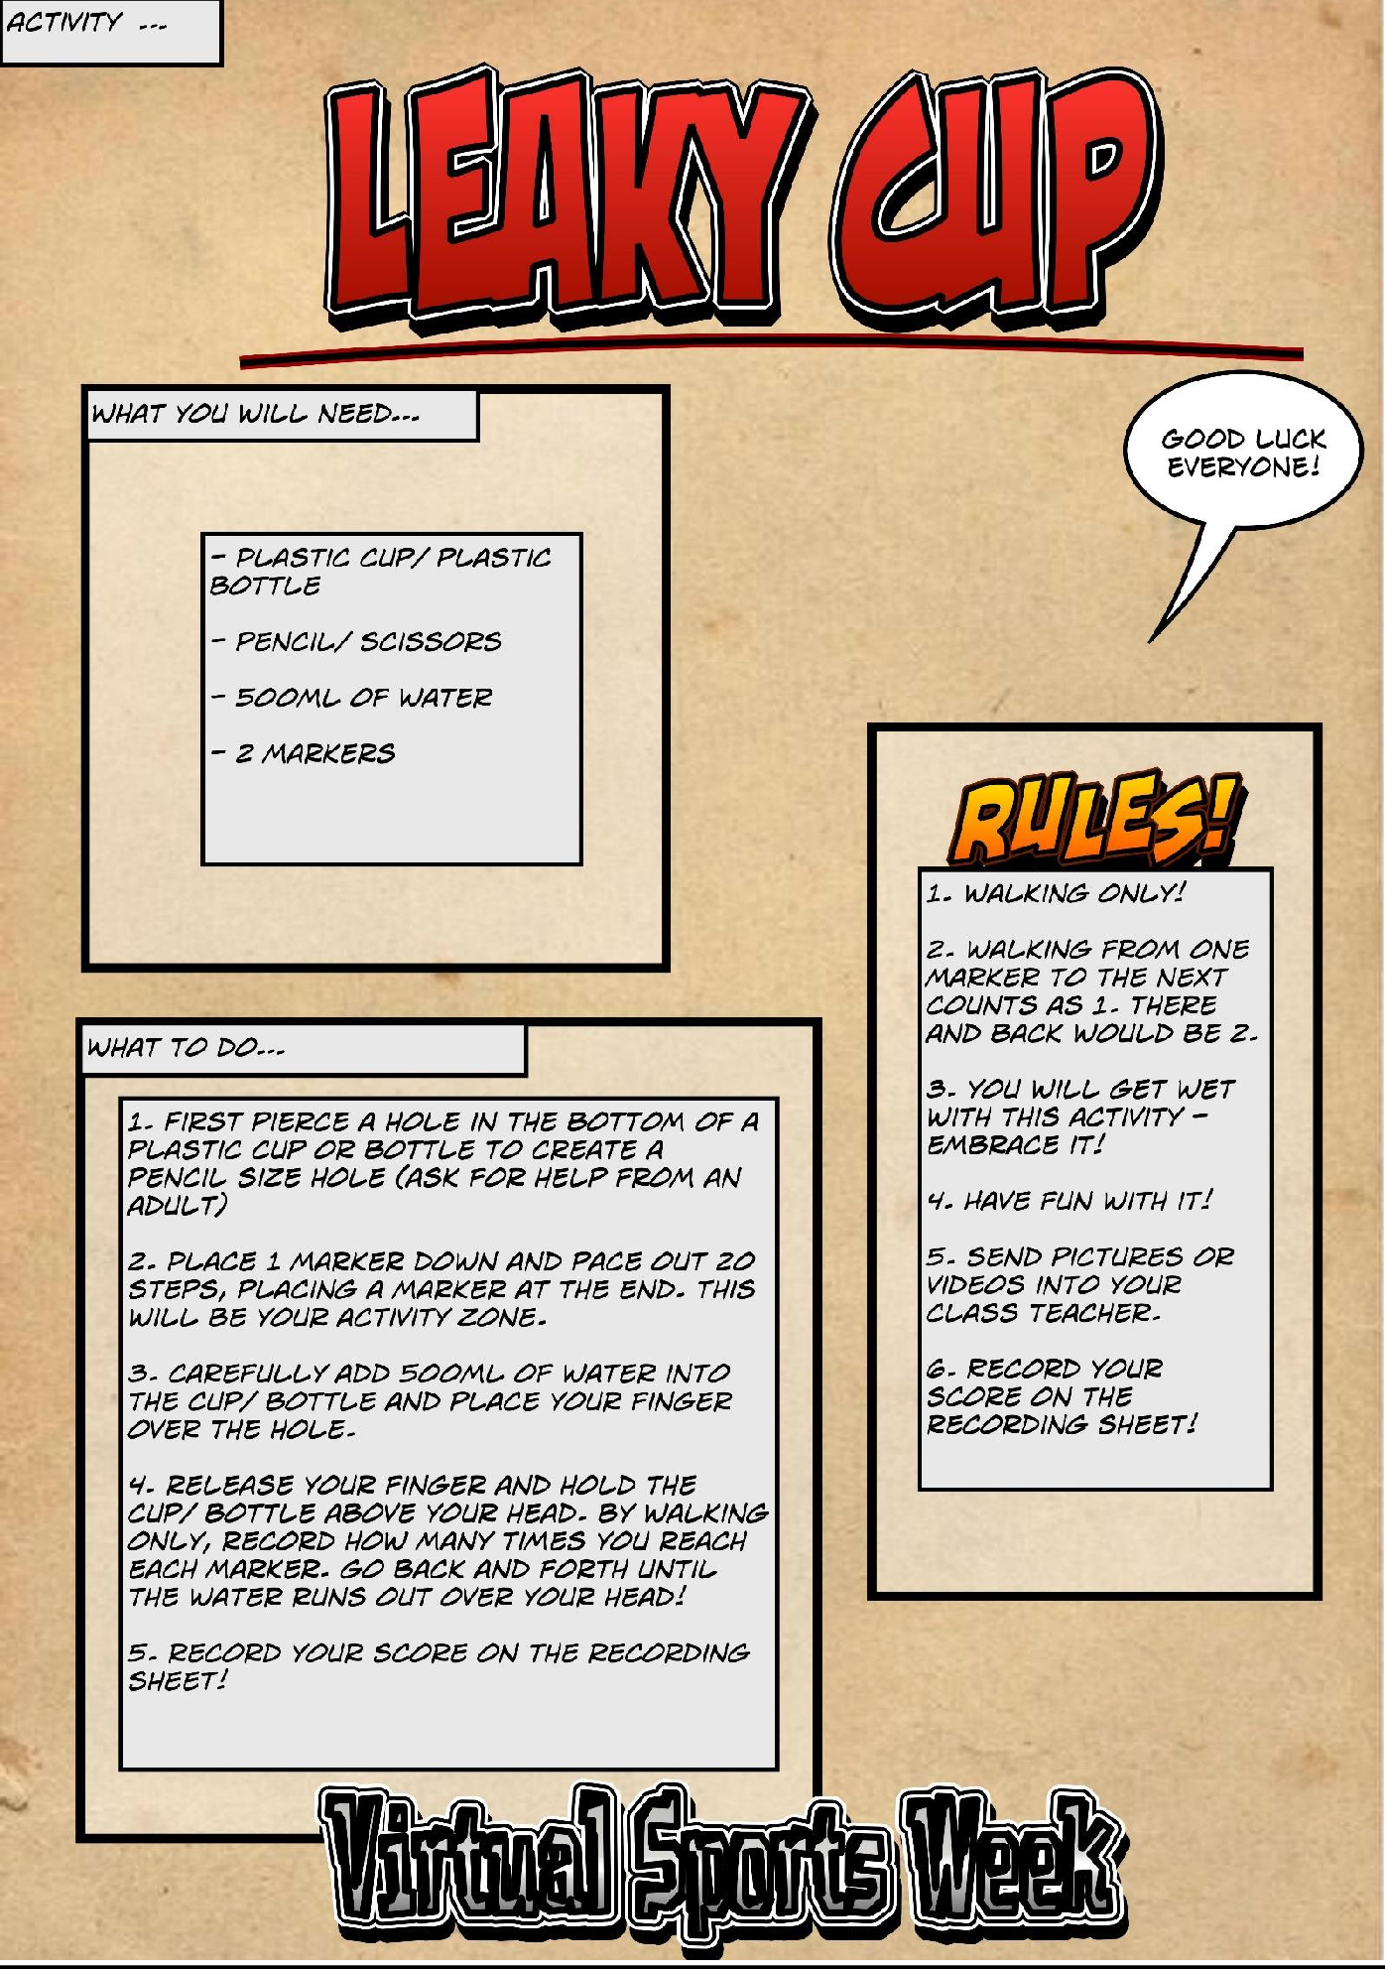

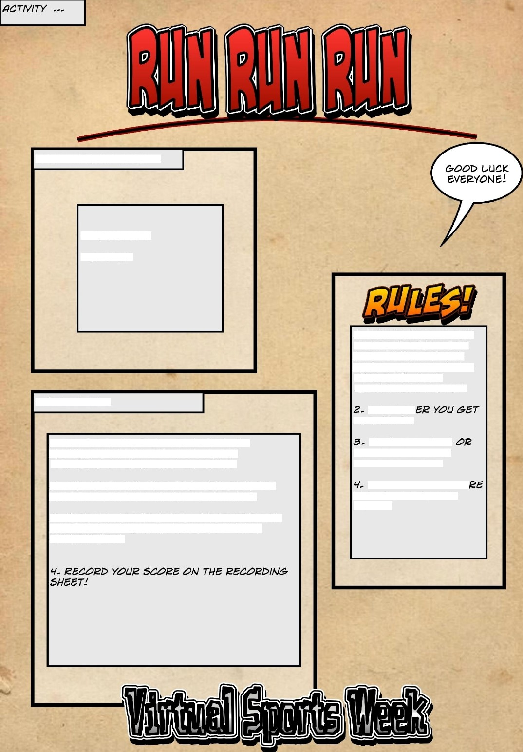
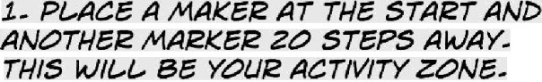
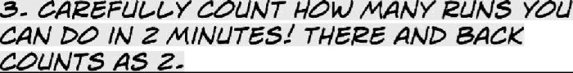
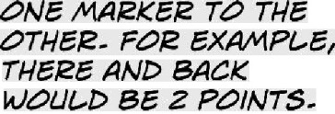

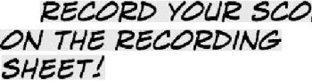

WHAT To Do---

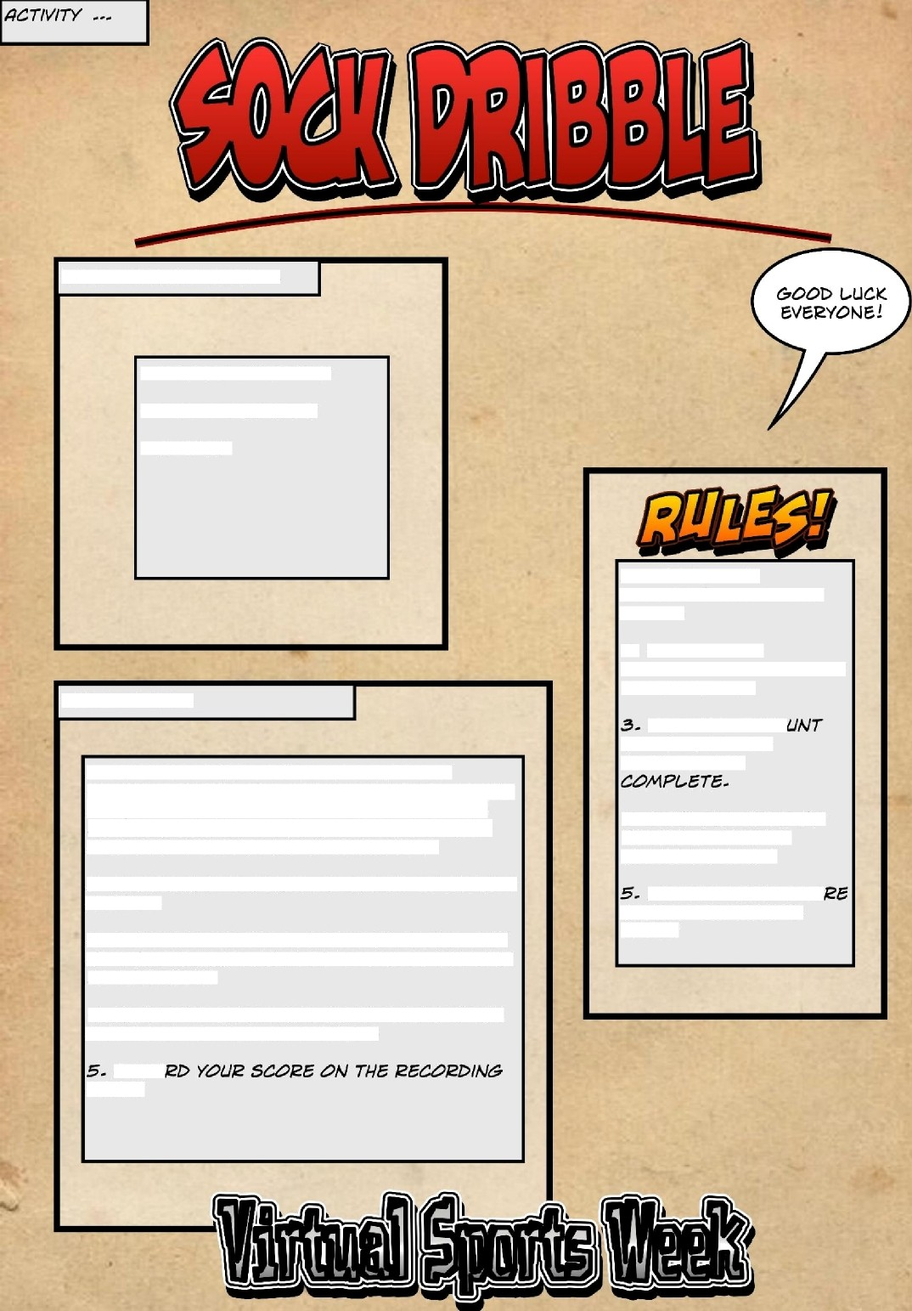
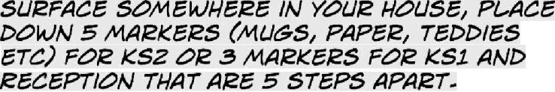
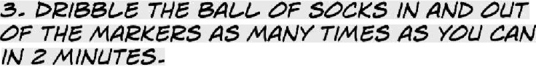
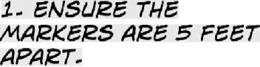
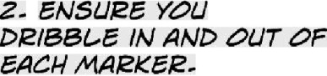
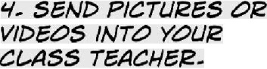


WHAT To Do---

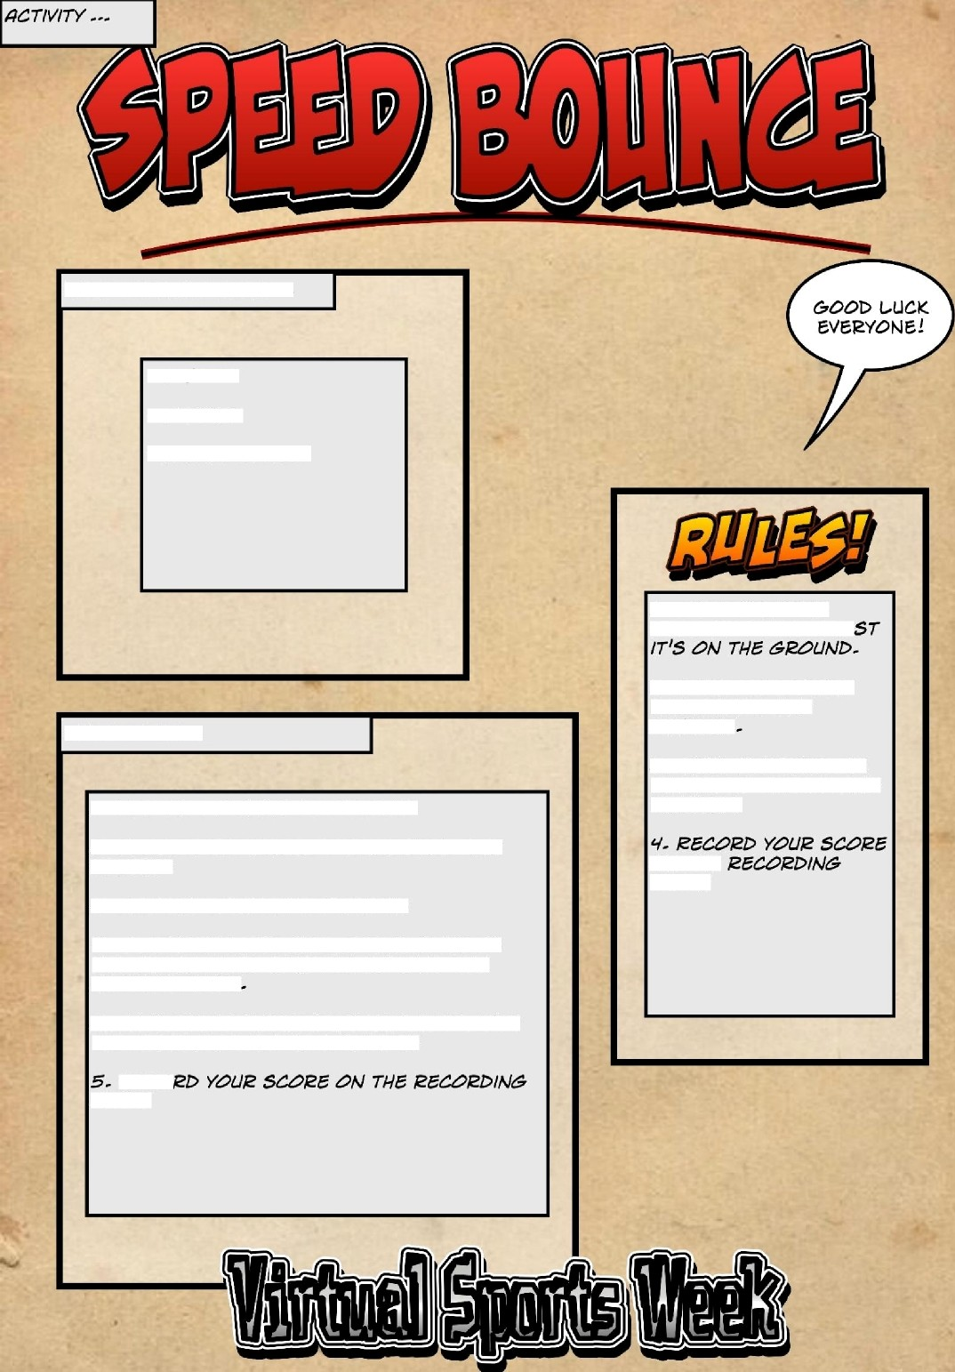
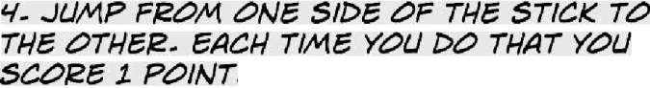
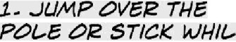
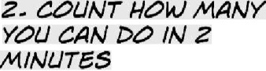
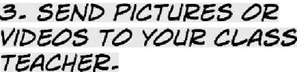
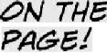

---
WHAT To Do:



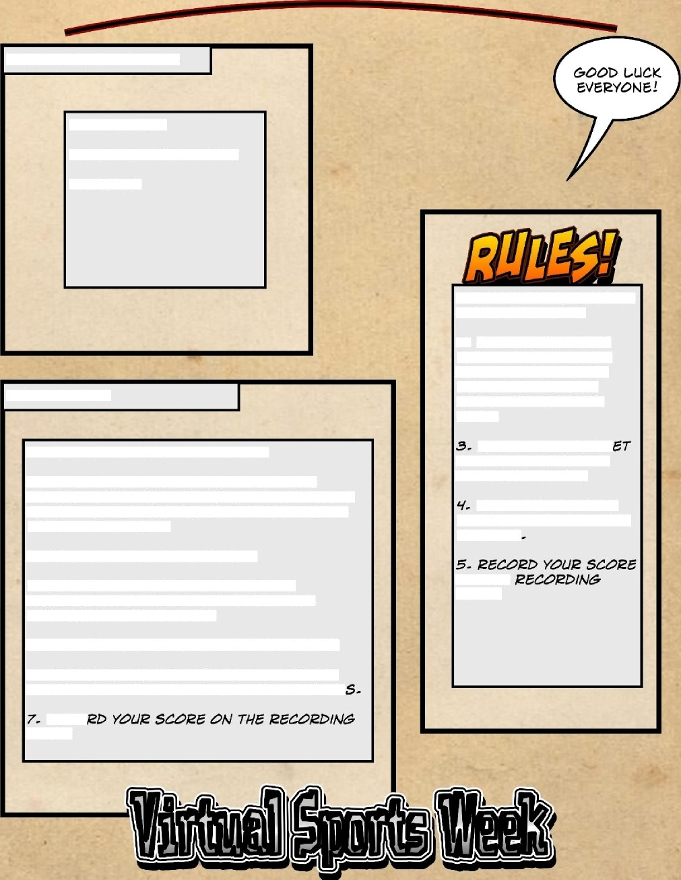
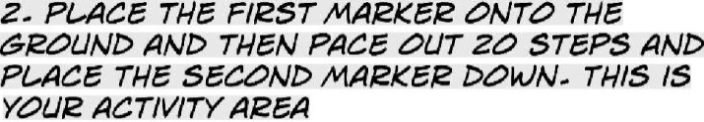
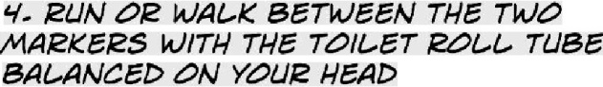
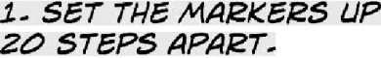
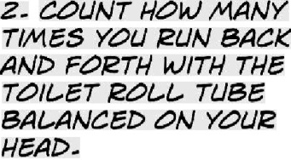
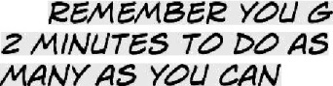

WHAT To Do---



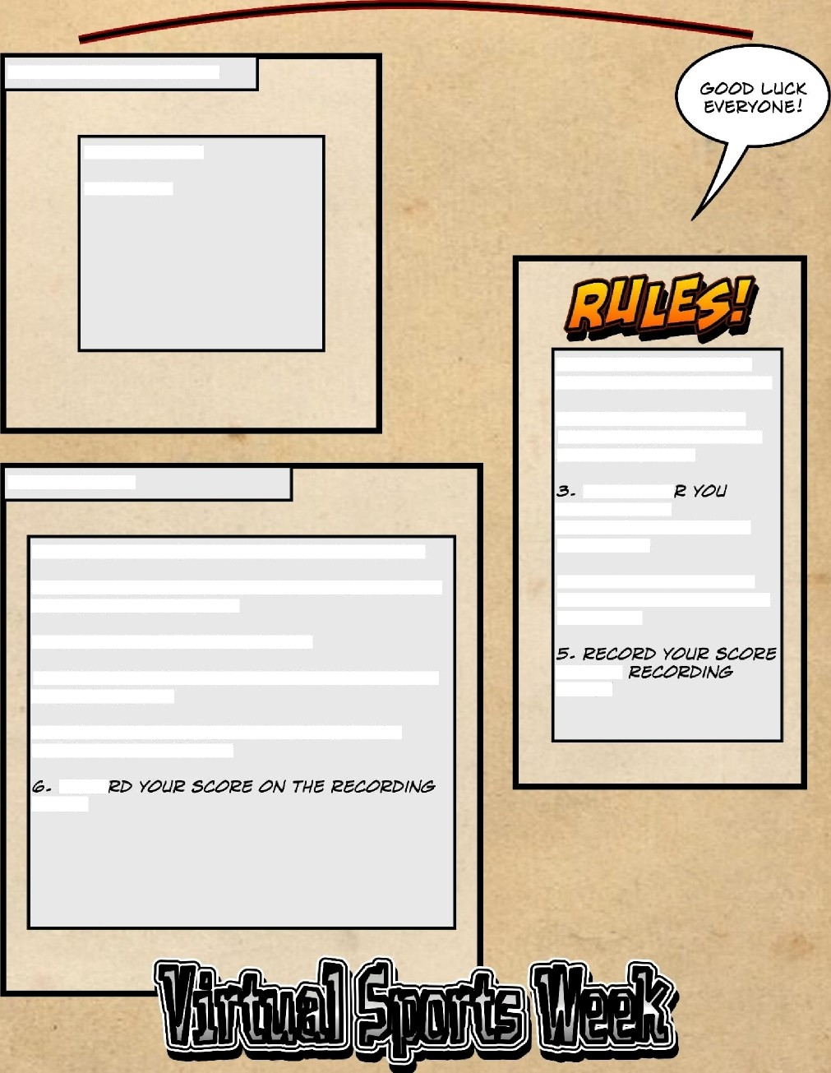
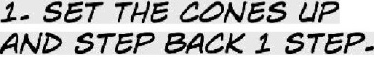
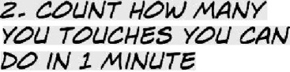

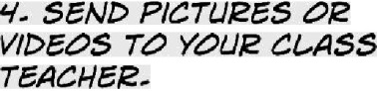
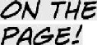

WHAT To Do---



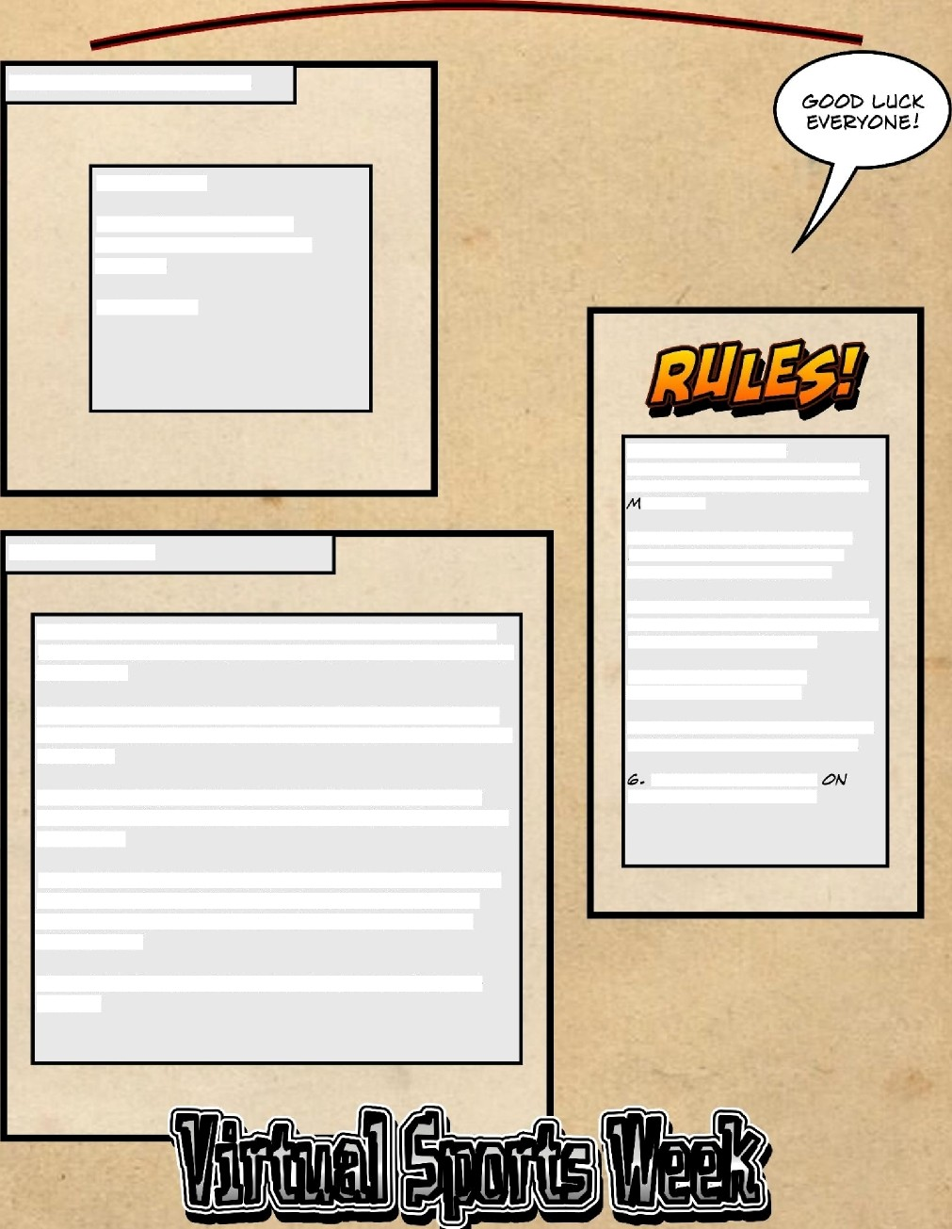
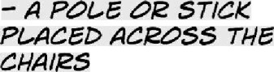
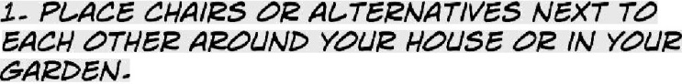
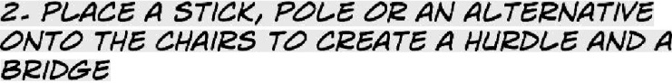
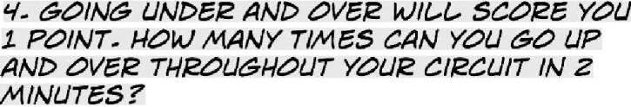
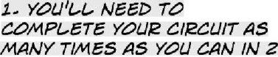
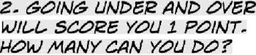
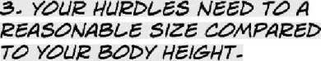
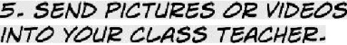
WHAT To Do---

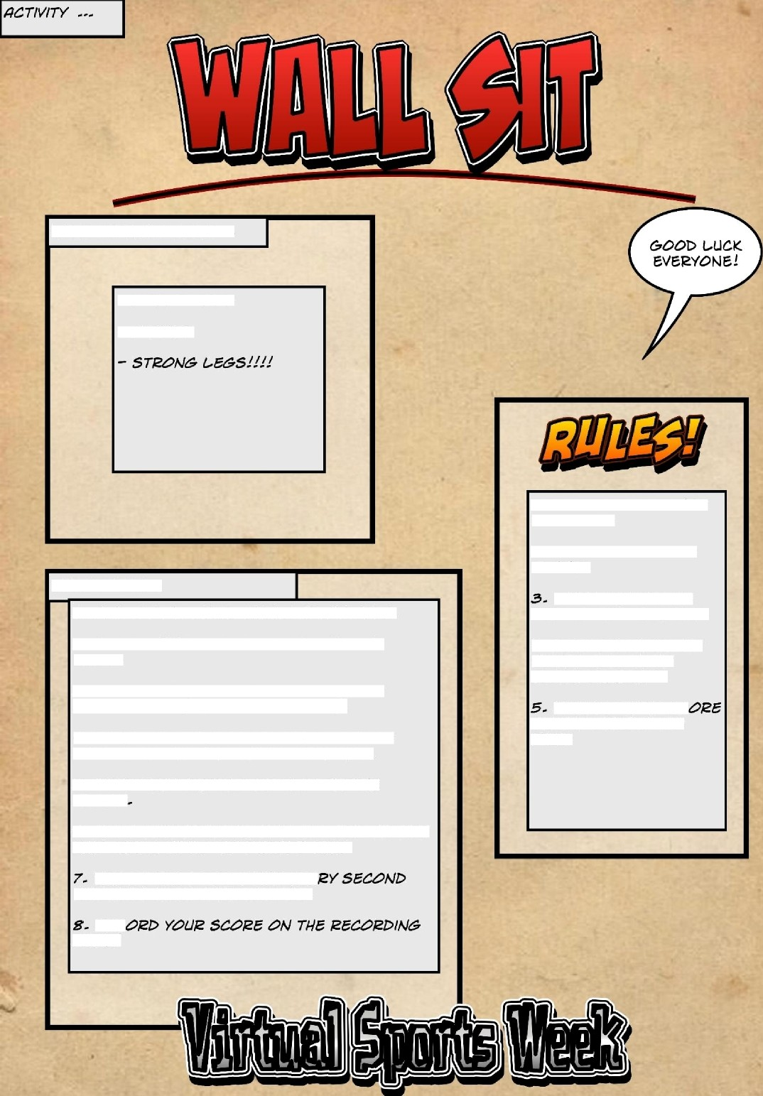
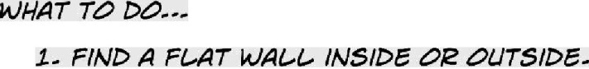

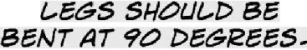
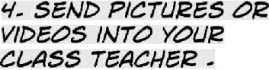


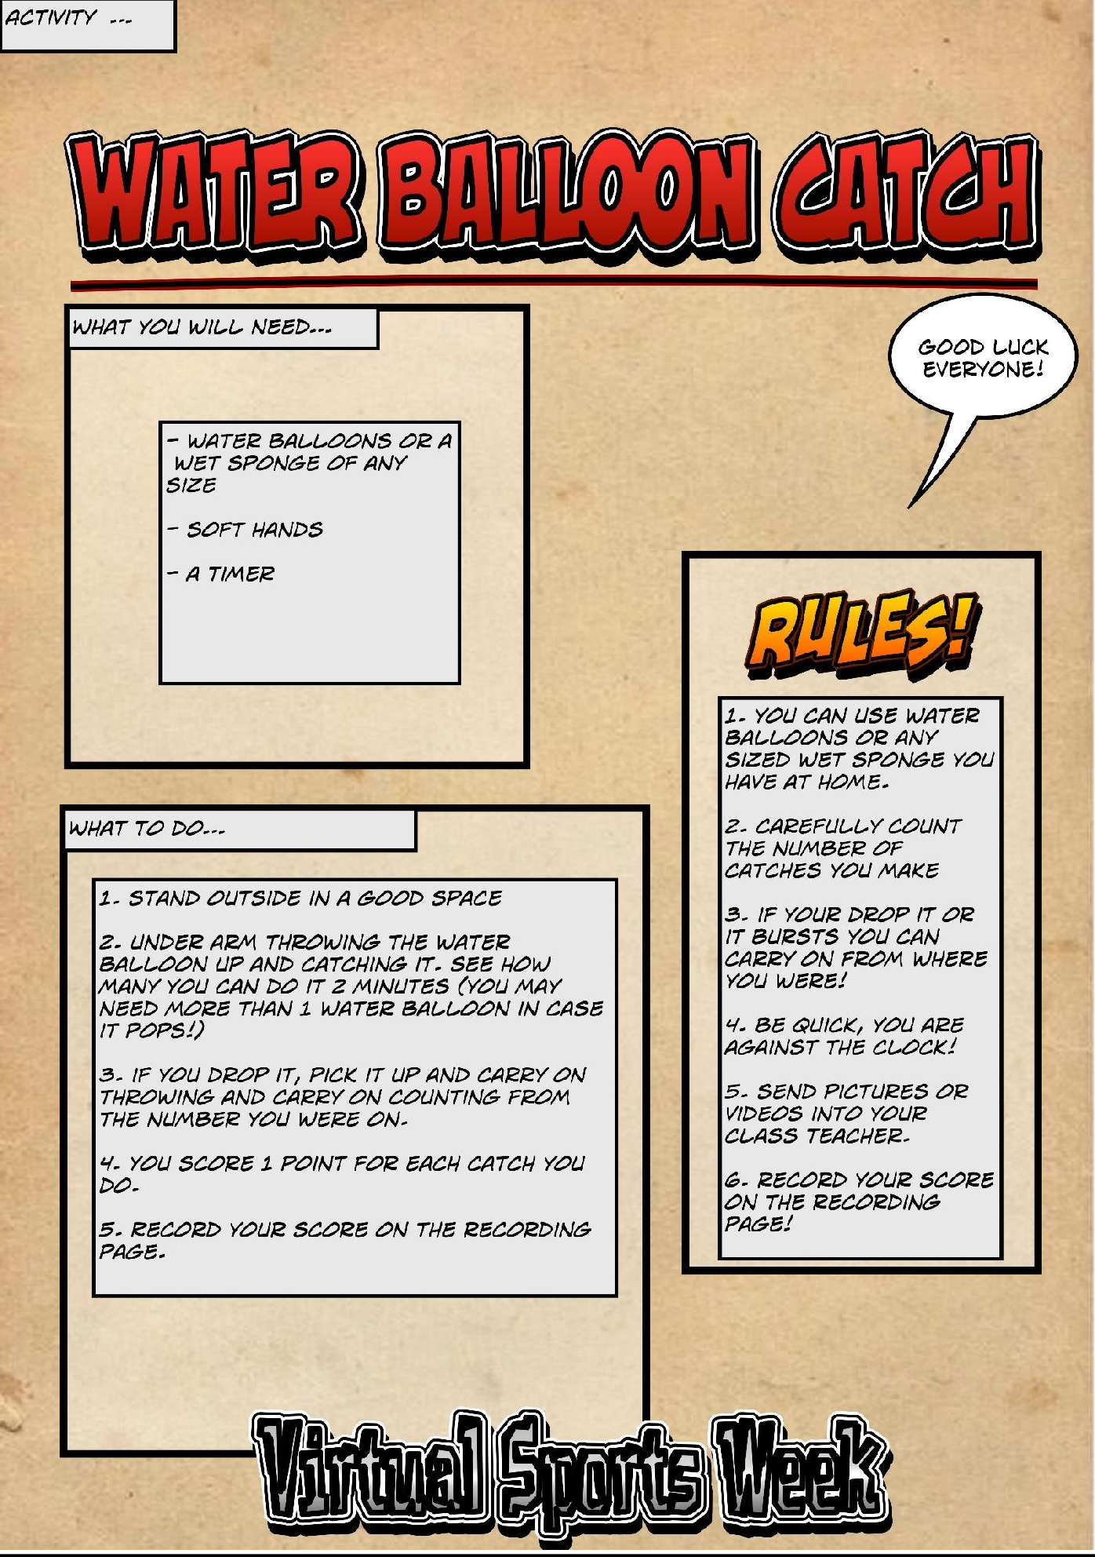

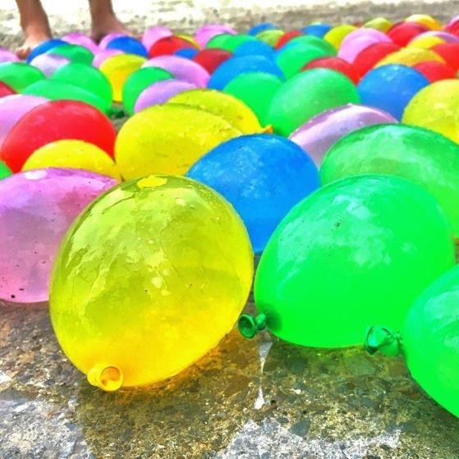
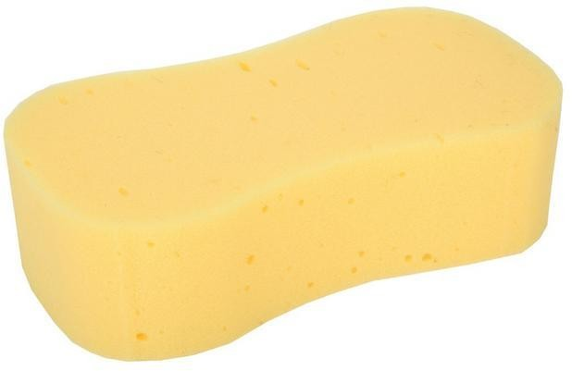
What you will need?
Some markers, a timer, a plastic bottle, Socks, 2 chairs, a stick or pole, a toilet roll tube, some water balloons (or sponges) and a plastic cup

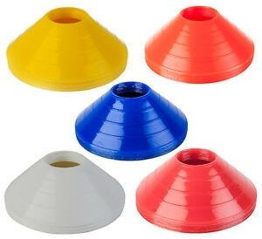
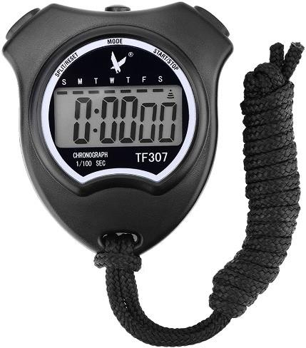
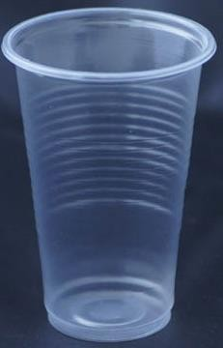
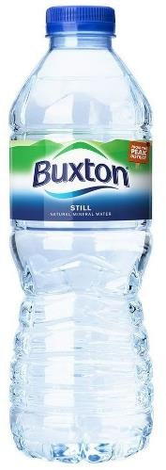
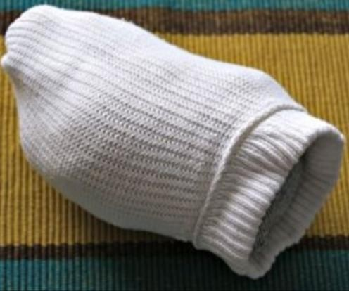
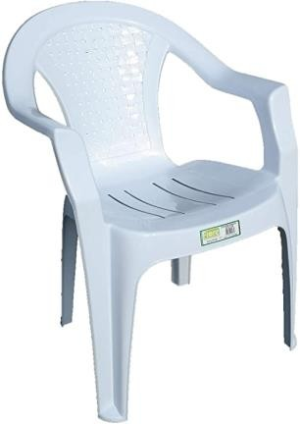
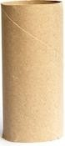

Recording Sheet Name:

Activity | Completed | Score/Time/Amount
Bottle Flip |  | Number of flips:
Leaky Cup |  | Number of lengths:
Run Run Run |  | Number of lengths:
Sock Dribble |  | Number of circuits:
Speed Bounce |  | Number of bounces:
Toilet Roll Run |  | Number of lengths:
Balancing Cone Touch |  | Number of touches:
Under and Over |  | Number of times:
Wall Sit |  | Seconds:
Water Balloon Catch |  | Number of catches:

