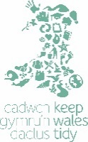
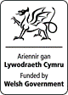


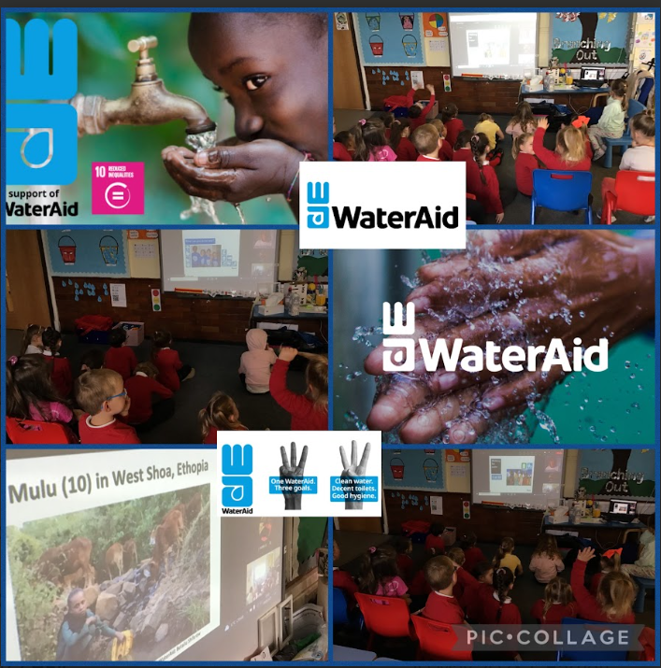
Water for Everyone!
We want water for everyone!
Article 24
Cwmaber Infants School
Caerphilly County
ECO-SCHOOLS WALES CASE STUDY


A Wish for Water!


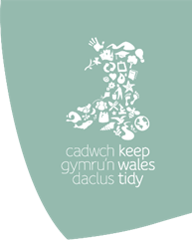
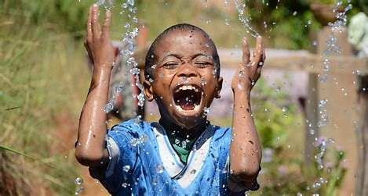

As part of our Summer term topic ‘Our Watery World,’ the Year Two children and Eco Warriors discussed how lucky we are to have a guaranteed supply of fresh running, clean water. They were surprised to find out that not all Countries have this luxury. They wished all countries could have this because all children have the right to clean water. (RRS Article 24)

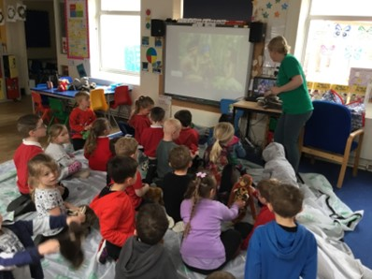




We celebrated our achievements during a celebration assembly. We also notified parents of our successes.

QUOTES

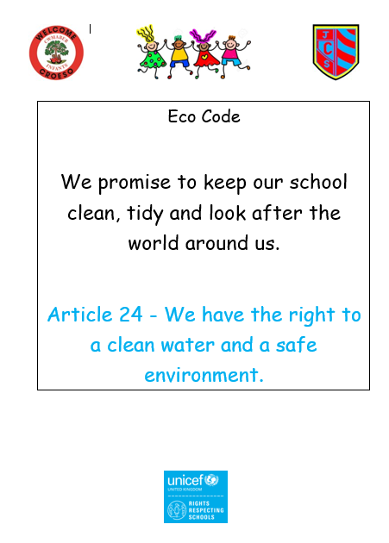
‘We need to start saving water.’ Ronnie Age 7
‘It is one of our Rights to have clean water and rights are very important.’ Thabo Age 6
‘The children have been extremely passionate about helping others to make sure we all have a clean water supply. ’ Mrs Cribb

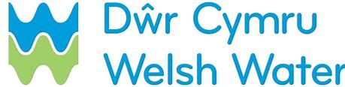

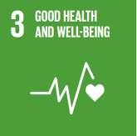

The children went further in their research to ensure all countries have access to clean water by raising money for the charity Water Aid. We also arranged a visit from Size of Wales workshop to discuss other steps we could do to help reduce climate change. Exploring Water Aid and the climate change workshop together the pupils could see that their actions as a whole can make a big difference when they work together as a group. We believe that we can continue this quest to save water in our school by using the water butts around the grounds to water the plants. We will also have water monitors to complete regular checks to see if taps are turned off around the school.

The children embarked on finding out ways to help those Countries without water. We arranged for Welsh Water to come in and show us ways to help save water. This was very useful for the pupils to demonstrate that they have the power to make a positive difference to our world.

Page 1
- Change the large image to one which represents your school Eco-Schools project. To do this:
  - Save the image that you plan to use onto the device on which you are completing this document.
  - Right mouse click on the image
  - Scroll down to ‘change picture’
  - Scroll down to ‘from file’ and click
  - The image should replace the stock field image
  - Resize as required.
- Insert name of your project below the main image. This should be from one of the targets on your action plan for the last academic year.
- Insert the name of your school and the name of your LEA
- Insert a brief introduction to your project – no more than two lines.
- Chose the UN Global Goals that your project meets. Choose up to three from the images below. To change the picture, copy the image from below, then follow instructions b and c above. When you reach point d scroll to ‘from clipboard’ instead. For more info go to www.globalgoals.org
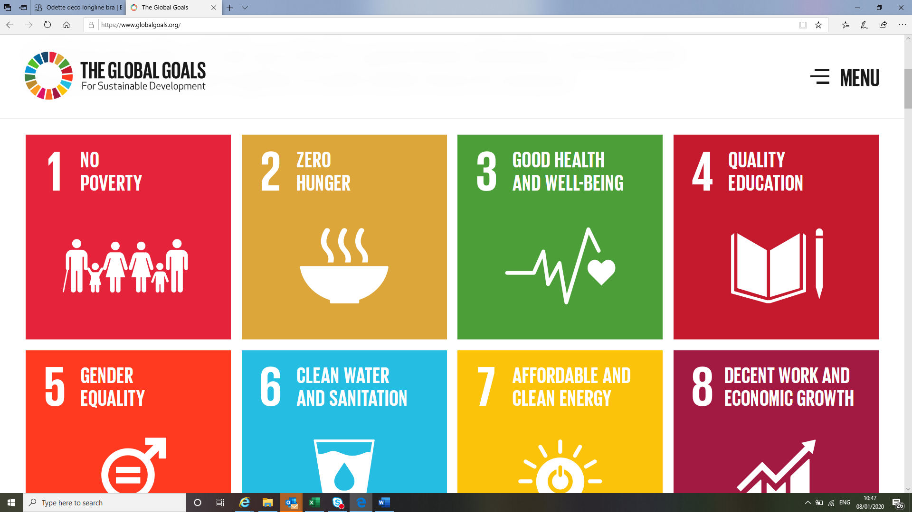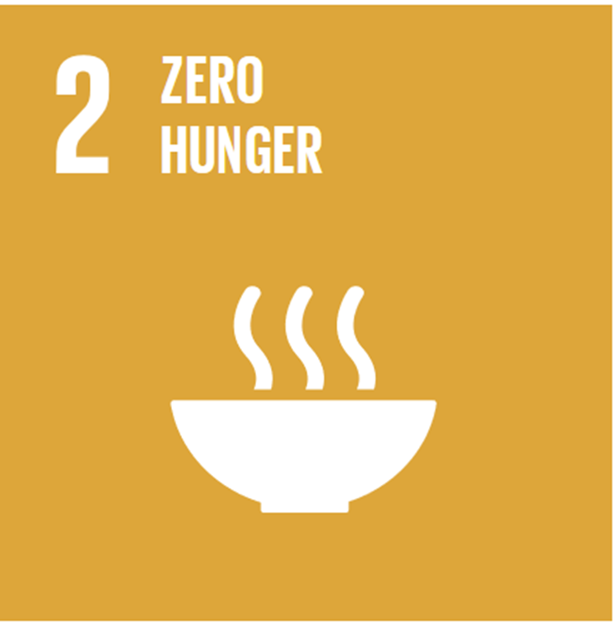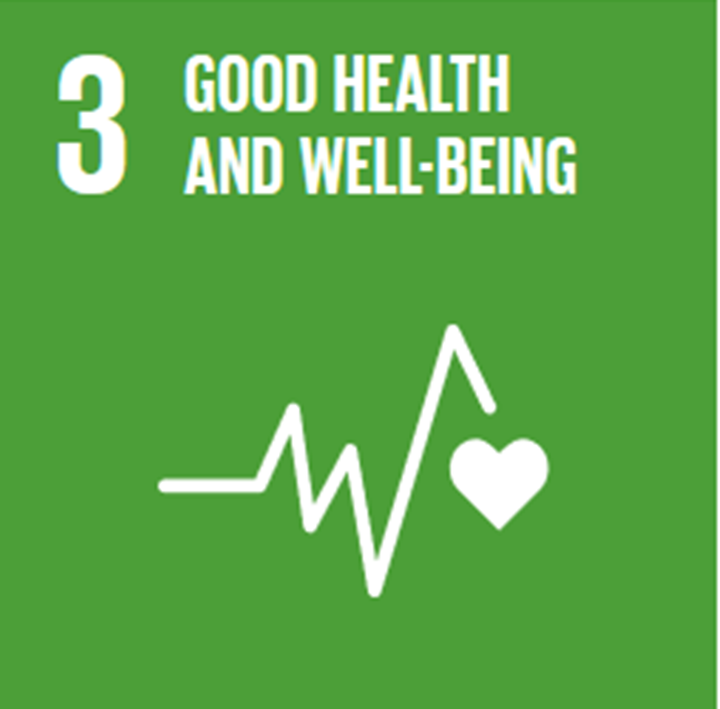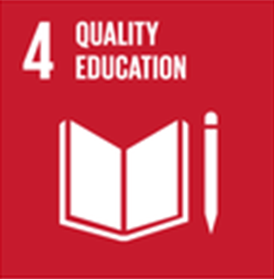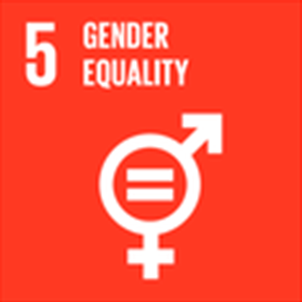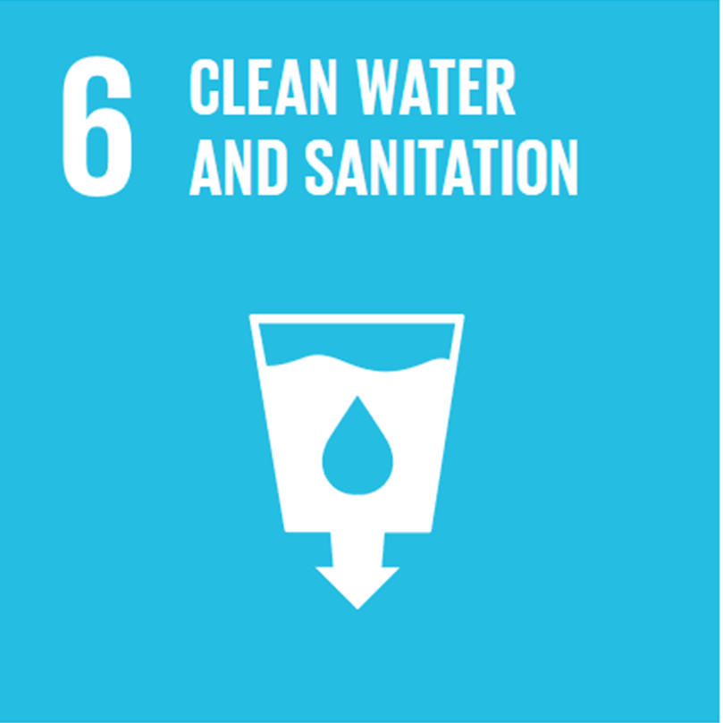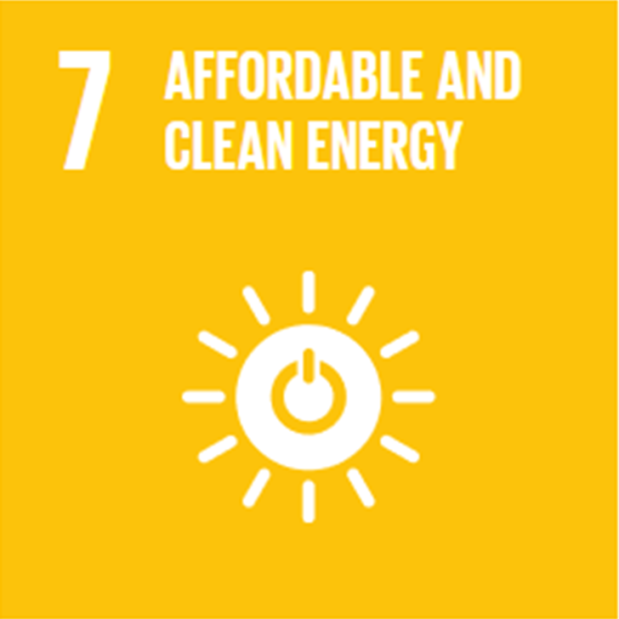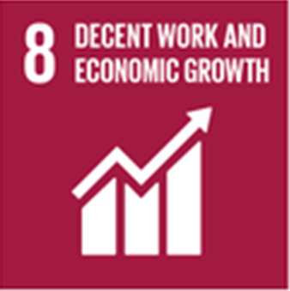
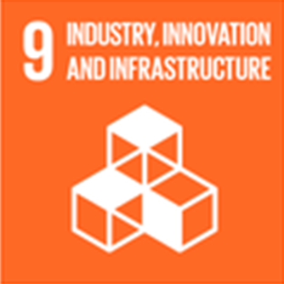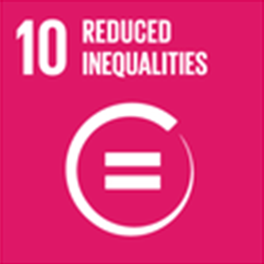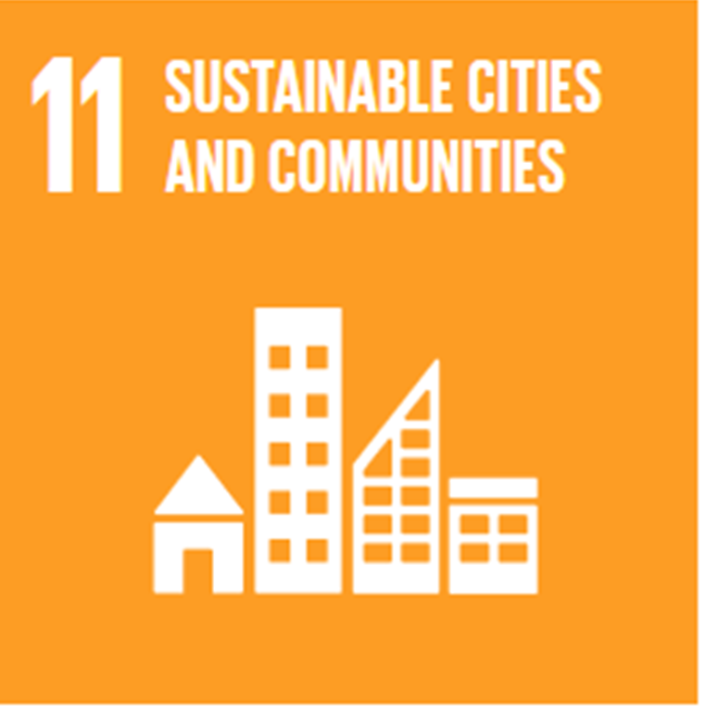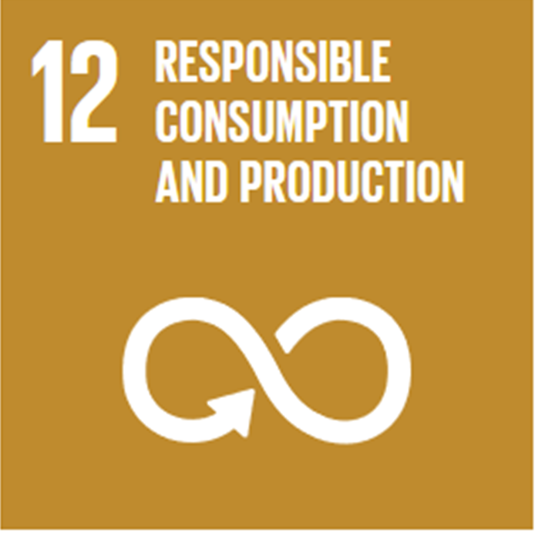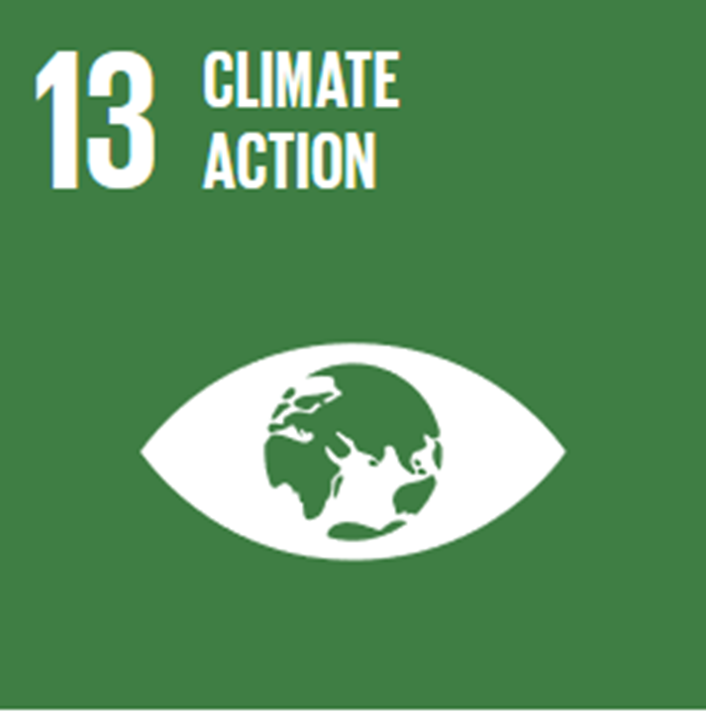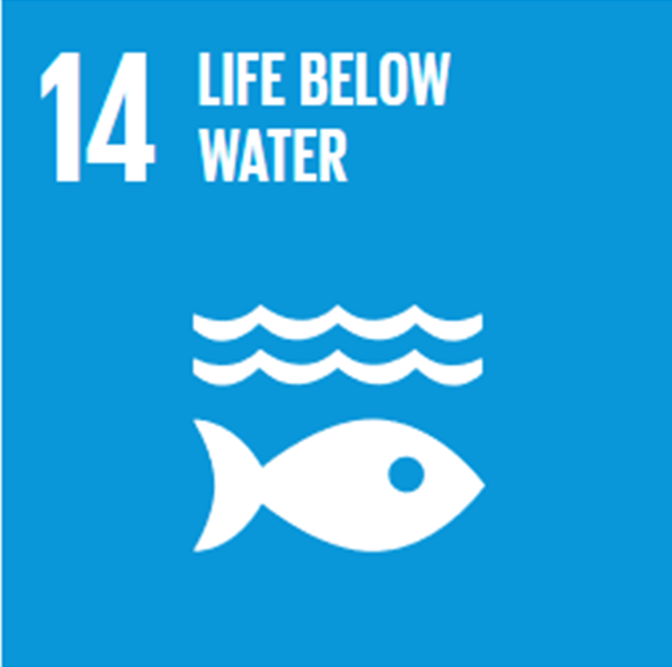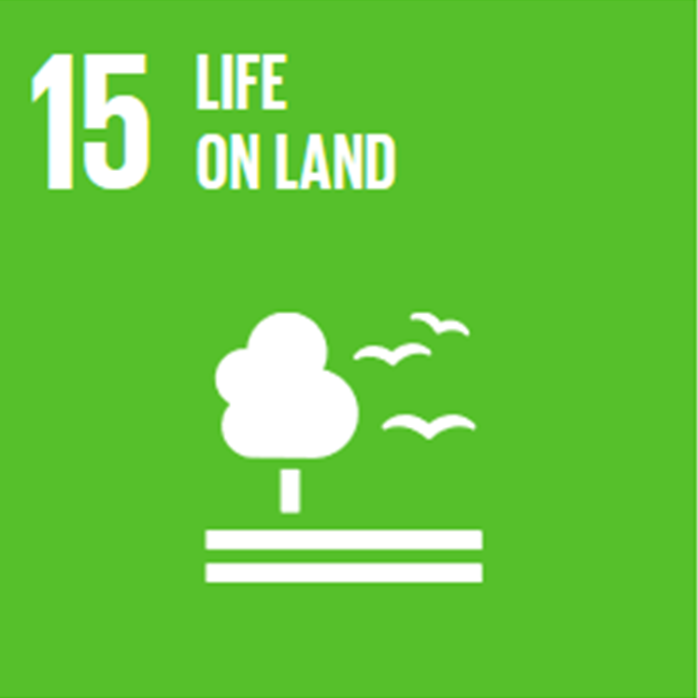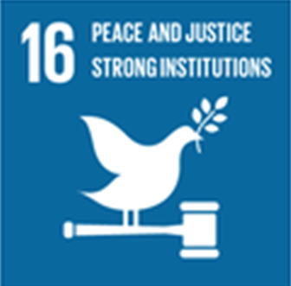
Page 2
- Please answer each of the questions in the boxes in full sentences. As you go through the questions you should see your story emerging.
- Replace the stock images to images from your project (using the guidelines from page 1 above)
- Quotes – Add two quotes. One should be from a pupil and the other from a teacher / Eco-Schools Co-ordinator at your school. Please include their name.

Document Guidance

