Letter sounds family 7

Please help your child to learn the letter sounds below.

Date:
qu
ou
oi
ue
er
ar

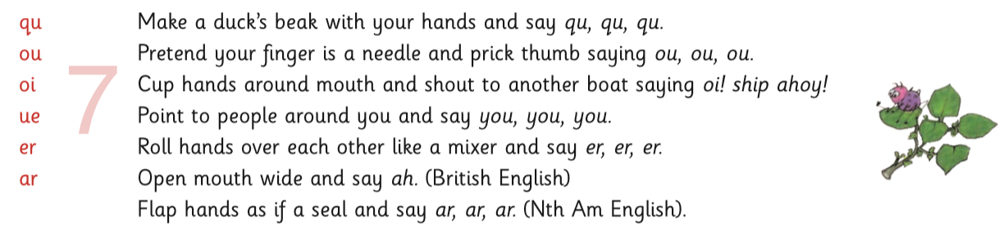

A parent guide to jolly phonics can be found by following the link below, scanning the qr code, or on the school website.

https://www.jollylearning.co.uk/jolly-phonics-catalogue/parent-teacher-guides/
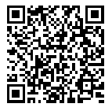
cwmaberinfants.com
>>parents
>>useful links

